**Moderate to Severe Evaluation**

Sample_id : **DEDTTT(Cat)**

Link:<https://release.animalbiome.com/pet/assessment/report/appendix/8eb5607a-685f-428f-9848-d691b9d576b2>

Cats and dogs:

Any two of the following:

(

High Red Flag Megamonas OR (failed)

High Red Flag Sutterella OR (failed)

High Red Flag Collinsella OR (failed)

Low Red Flag Bacteroides OR (**passed**)

Low Red Flag Blautia (**passed**)

);

OR

Cats:

11 or more yellow flags;(failed)

OR 9 or more red flags;(**passed**)

High Red Megamonas,High red suttrella and collinsella failed.

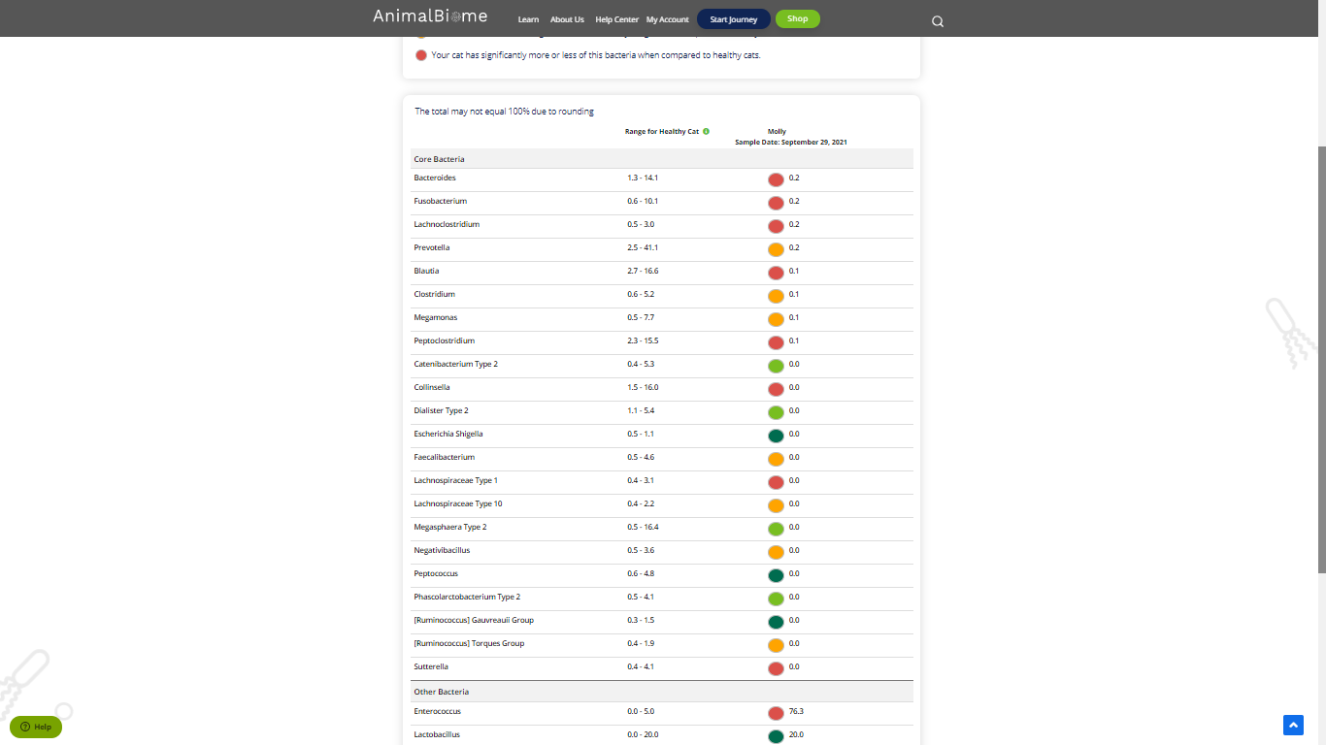

Low group evaluation:

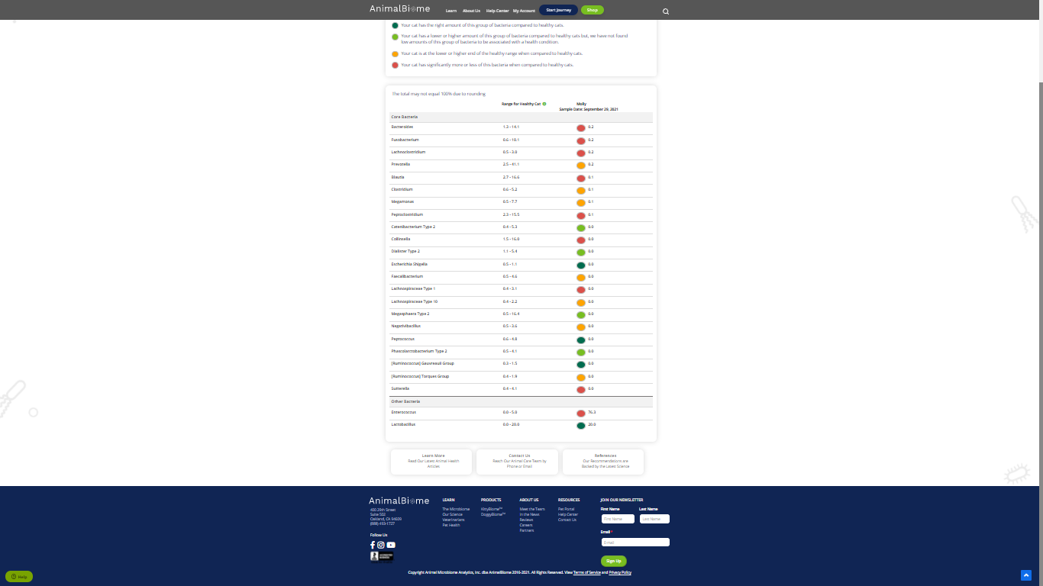

low red blautia : Passed.

Low red bacteroides : Passed (2 conditions satisfied ) in the primary group.

Total yellow flags : 6

Red flags : 9

The result : **True False True**

Moderate to severe results:Pass

Expected result : **Moderate to severe**

Achieved result : **passed.**

